NAME: _______________________________

Some Common Writing Errors in HASS
- Take note of the marks awarded for each task – they generally indicate the number of key points that are required in your response.

- During an assessment, take note of the time you have left and allocate those minutes in value to each task – don’t spend too much time on one section and neglect the opportunity to complete others that may award additional marks. By leaving some sections unanswered you are ‘throwing away marks’ that you could have ‘picked up’.


- Read the set tasks carefully – often students glance at this and ‘think’ they know what is required. This leads to needless inaccurate responses, or only partially completing a set task because the expectation was misunderstood.


- If you are unsure of a task, raise your hand and ask for clarification. If you are unsure of the answer, and there is time left during the assessment, ‘have a go’ and place something logical as a response - your best guess is likely to pick up a mark or two; you have nothing to lose.


- Never simply begin your answer with the raw response. Always start your response so the reader can clearly see what you are addressing. A good rule to follow is to convert the question or task into your opening sentence, i.e. ‘What caused the conflict?’ - ‘The causes of the conflict were……’, or ‘’Describe the similarities and differences between……’ - ‘The similarities and differences between ____and ____ are……’


- When time is available, proof read your response again and double check with the set task to assure yourself that you have addressed what is required of you to maximise your marks.
- When asked to ‘define’ something this means to describe it clearly using a range of other descriptive words, not the same word that you are meant to be defining.


When asked to ‘explain’ something this means to offer a broader and deeper description of the idea, concept or event beyond a simple definition.



- When asked to provide an ‘example’ this means to give the reader something they may be familiar with so they can recognise what they already know with its comparison or shared identity to what you are explaining.


- Watch your basic grammar: sentences always start with a capital letter; people’s names, places, countries and major events should always have a capital letter; sentences always end with a full stop; dot points do not have full stops.

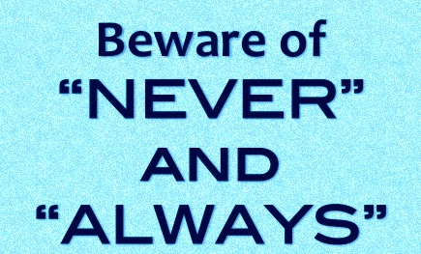
- When writing about society and in particular when discussing what whole communites did, try to avoid using absolutes such as: ‘everyone’; ‘all’; and ‘nobody’ etc. as this cannot possibly be true. Instead, be mindful to use: ‘most’; ‘few’; ‘many’ ‘the majority/ the minority’ etc. as this is more likely the case, depending on your evidence.

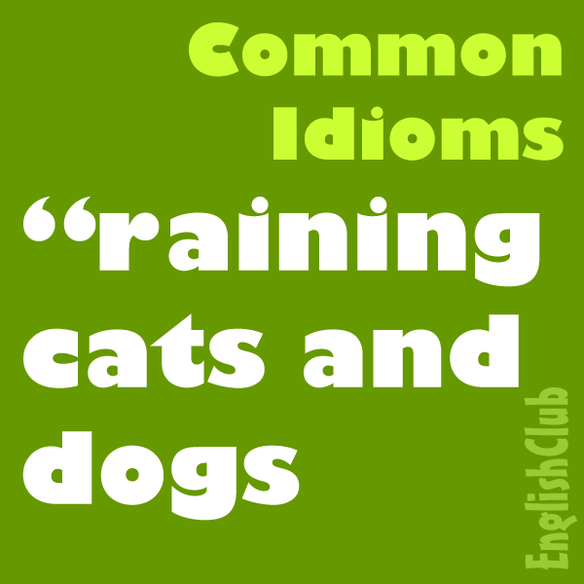
- Try hard to avoid writing with the use of idioms. Idioms are a word or phrase which means something different from its literal meaning. They are often common phrases or terms whose meaning is changed, but can be understood by their popular use, such as ‘over the moon’; ‘the last straw’; ‘the best of both worlds’; ‘cutting corners’. If idioms are used within your text, you must place them in inverted commas and then explain them clearly to avoid any ambiguity (something that has more than one meaning) as this makes your explanation less clear and can be confusing to the reader.

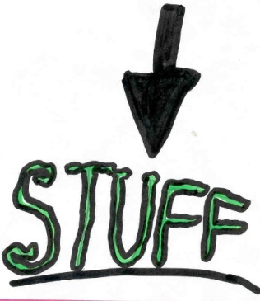
- Using the word ‘stuff’ when describing something, is not really acceptable – it is vague and non-descriptive; in fact, it ‘stuffs up’ the clarity of your response (to use an idiom) meaning it should be replaced by a specific item or article to help the reader recognise what you are discussing.

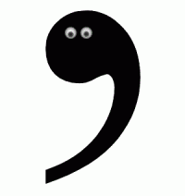
- Apostrophe: if you are discussing something and it belongs to a person or a group, you must place the apostrophe in the correct place, e.g. the leader’s plans; Tommy’s thoughts, etc. If the person already has an ‘s’ at the end of their name to title, there is no need to place another ‘s’ after the inverted comma, e.g. Robert Menzies is a famous Australian prime minister during the mid-20th century . As his name already ends in an ‘s’, possession for Menzies would appear thus: Menzies’ speech.

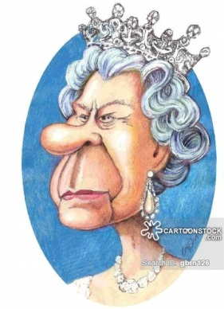
- When discussing the title of someone and their position in society, such as a god, king, queen, pope, prime minister, president, etc. it should be written with a capital, e.g. God’s commandments, King Richard I, or, Prime Minister Curtin. If you are simply discussing a role in general terms, such as ‘their god’ or ‘someone tried to become a king or prime minister’, these are discussing the term, not a specific person or the title they own, and therefore it remains as a lower case, without capitals.

- Words that often get confused and should not be used in the wrong context:
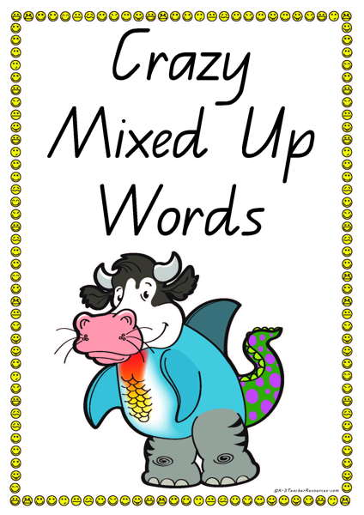
- This led to further changes.
- The piping was made from lead.
- She took the dog for a walk on the lead.

- Other common errors: ‘Affect’ – to inflict, or have an influence on something or someone. ‘Affect’ is a verb; a doing word or action. ‘Effect’ – the result or consequence of an action. ‘’Effect’ is a noun; to identify a thing, person, object or situation.
An example: The sports’ coach affects the players positively by taking them through a rigorous training regime. The effect is that the players improve in their skills and challenge the stronger teams.
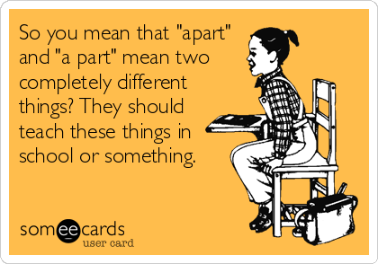
More common errors:
‘’A part’ – a section or segment of something.
‘Apart’ – separate from something.
An example: A part of the plan was to cleverly divide the two groups apart .
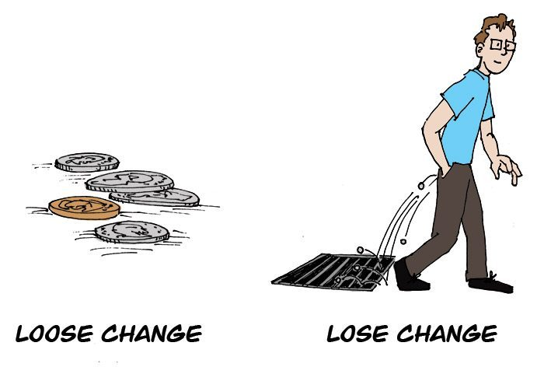
‘’Lose’ – be deprived of, or cease to have or retain something.
‘Loose’ – not firmly or tightly fixed in place; detached or able to be detached.
An example: The loose straps on the trailer caused the farmer to lose some of the bales as he drove down the track.


‘’Were’ – the past form of the word 'are'.
‘Where’ – at, in, or to what place or position.
An example: They were attacking the city during the year 1095 CE. That is where most of the atrocities occurred.

‘’Their’ – belonging to or associated with the people or things previously mentioned
’There’ – in, at, or to that place or position.
An example: They decided that their strategy would be to attack the enemy over there on the following day.
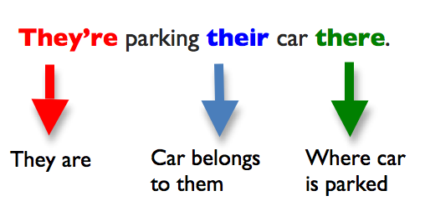

- Common spelling or grammatical errors:

Incorrect: ‘They did that cause they had to’.
Correct: They did that because they had to’.

Incorrect: ‘That would of been a terrible time’.
Correct: ‘That would have been a terrible time’.

